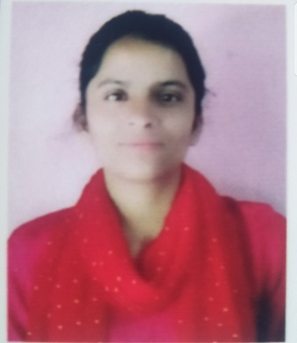**RESUME**

SAKSHI SHARMA

+91 96221 81595

Email id: [ss5731230@gmail.com](mailto:ss5731230@gmail.com)

OBJECTIVE

To work with an organization where can learn new skills and increases my abilities for the organizational goals as well as myself.

EDUCATIONAL QUALIFICATION

* Pursuing B. tech 4th year from Rajasthan Technical University
* Passed out 12th from J&K Board in 2018

Marks 69.6%

* Passed out 10th from J&K Board in 2016

Marks 58.6%

TECHNICAL SKILLS

1. C
2. C++
3. Python
4. HTML
5. CSS

WORK EXPERIENCE

FRESHER

STRENGTH & HOBBIES

* Hard & Smart Working
* Honest and Punctual
* Good Communication Skill
* Cooking, Drawing, Singing, Reading books

PERSONAL DETAILS

Father’s Name : Sh. Gori Lal Sharma

D.O.B : 08-06-2001

Address : Village- Upper-Bidda, Tehsil-Nagseni,

District-Kishtwar, State- Jammu & Kashmir,

Pin-Code-182204

Marital Status : Single

Date………………….. (Sakshi Sharma)